Three Main Logic Gates

AND Logic gate:

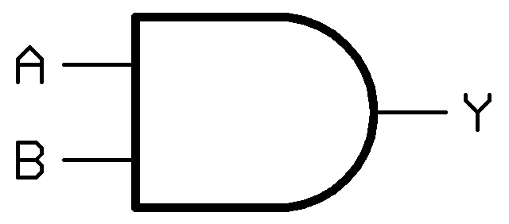

An AND logic gate is a basic digital logic gate that implements a logical conjunction. This logic gate behaves in terms of the following truth table:

|  |  |  |
| --- | --- | --- |
| INPUT | | OUTPUT |
| A | B | A **AND** B |
| 0 | 0 | 0 |
| 0 | 1 | 0 |
| 1 | 0 | 0 |
| 1 | 1 | 1 |

A and B indicate an input, which is either 0 or 1 in terms of binary. It is only when both A **AND** B are 1s that the logic gate will pass the output as a 1 (hence the name AND.)

OR Logic gate:

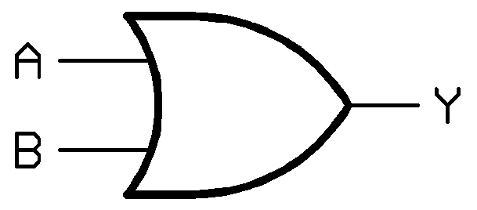

An OR logic gate is also a basic digital logic gate that implements a logical disjunction. This where either A or B has to be a 1. This behaviour can once again be proven with the aid of a truth table:

|  |  |  |
| --- | --- | --- |
| **INPUT** | | **OUTPUT** |
| **A** | **B** | **A AND B** |
| 0 | 0 | 0 |
| 0 | 1 | 1 |
| 1 | 0 | 1 |
| 1 | 1 | 1 |

In this case A and B are once again inputs to the logic gate. If any one of these two inputs contains a “high voltage” then the gates output will be passed a 1.

NOT Logic gate (AKA Inverter):

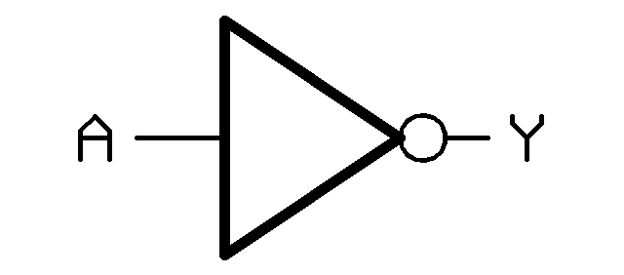

Unlike the other two logic gates, which have two inputs, the NOT logic gate only has one input a high voltage or a low voltage. This too can be shown in a truth table:

|  |  |
| --- | --- |
| **INPUT** | **OUTPUT** |
| **A** | **Y** |
| 0 | 1 |
| 1 | 0 |

If the voltage is low then the logic gate will make the output a higher voltage. If the voltage is high then the output will be a lower voltage. It basically inverts the input.